Creating a ShoWorks Passport account on the Computer
There are two ways to sign up for a ShoWorks Passport account. This informational page shows how to get a Showorks Passport account through the computer. If you don’t have access to a computer, You can set up an account on the Passport App by making sure that you enter the registration information EXACTLY how it appears on your receipt.
Go to https://bee.fairwire.com/ and click on Sign In
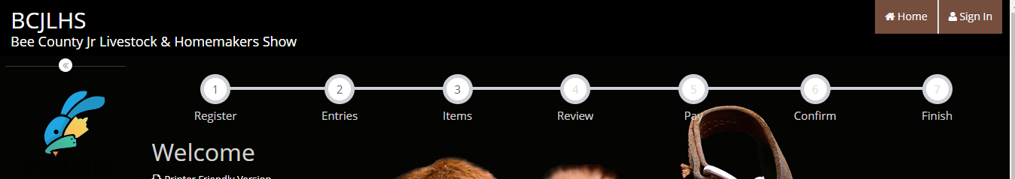
Choose I am “passport” from the dropdown box
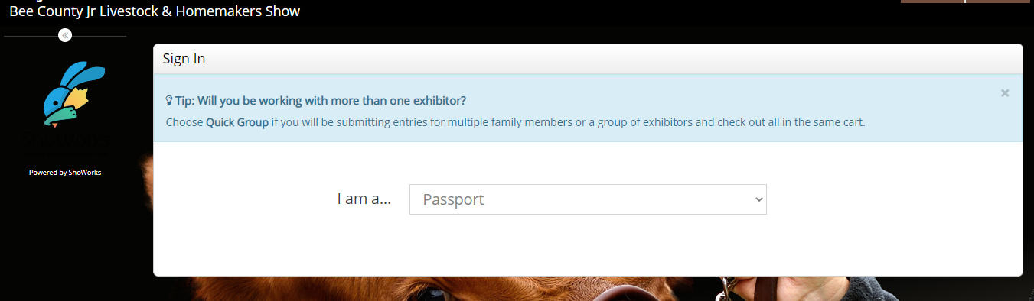
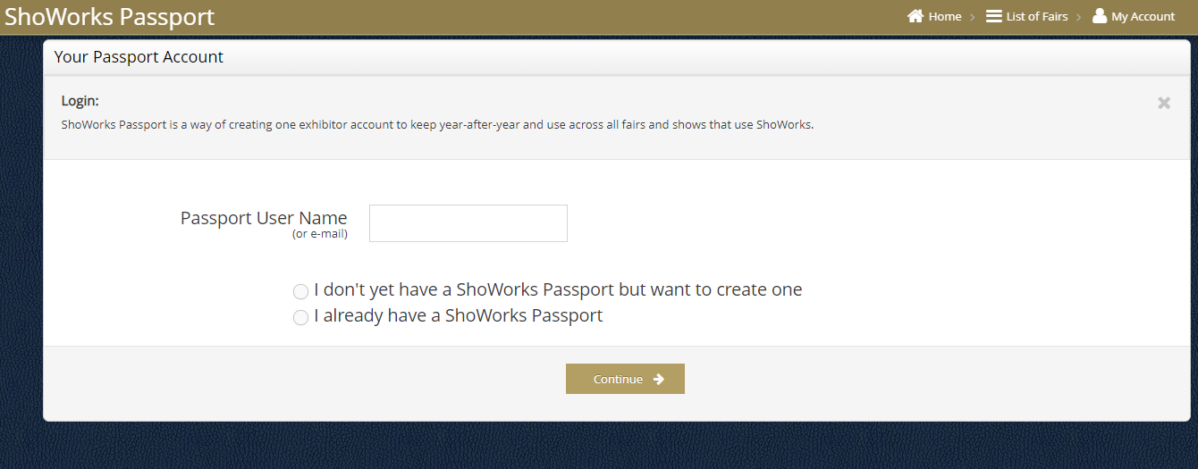
Choose a user name and select “I don’t yet have a ShoWorks Passport but want to create one” You may want to make the user name child specific since you must make a separate account for EACH child you have exhibiting.

Make sure the information you enter here is EXACTLY the same as what you entered on your receipt. This is how the Passport account will connect to your exhibitor’s information. Upon completion of entering this information, click “Continue”
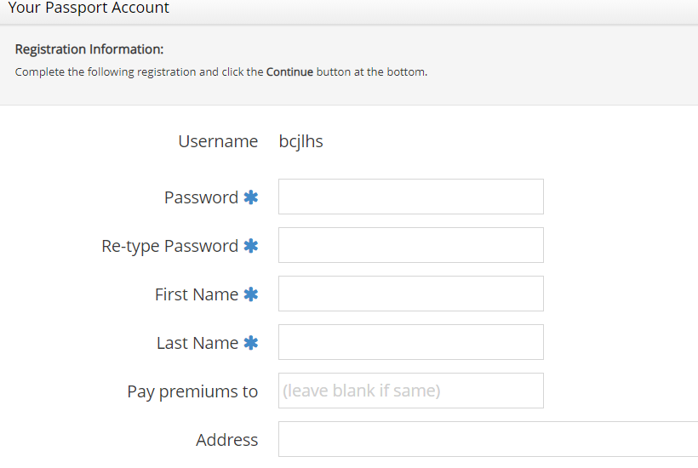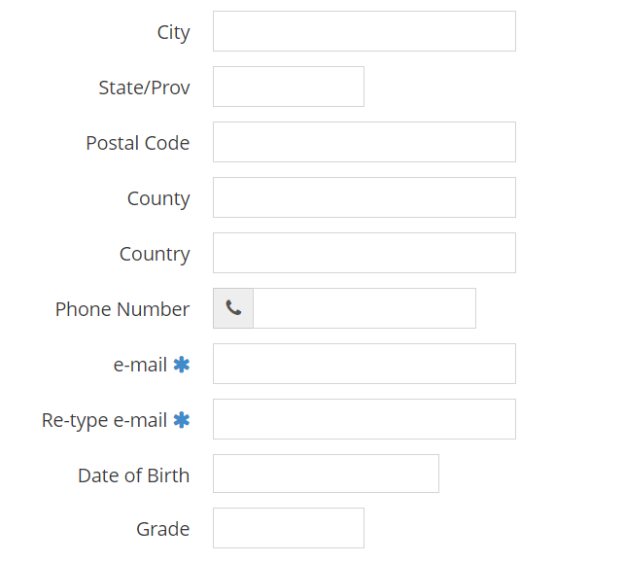

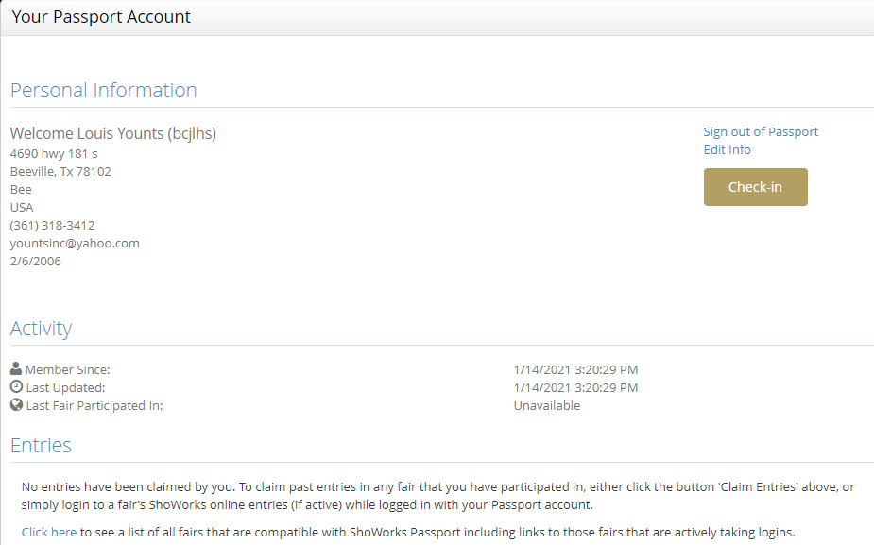

If no entries are showing, please click on the button that says “Claim Entries” and it should populate your account with your current year and possibly even past years entries.
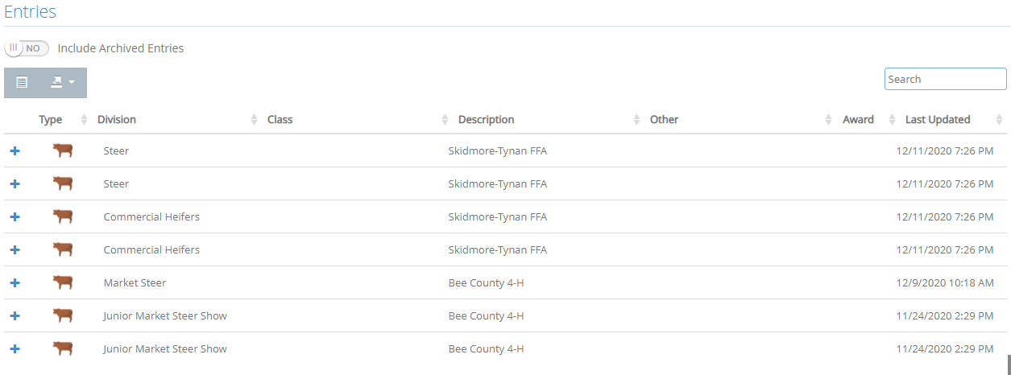
If you are still having problems, please email bcjlhs.superintendent@yahoo.com with your student’s name and Date of Birth so we can send it to the IT Department.
These directions are for creating an account. If you have already created an account but were unable to connect to your child’s entries try logging in and clicking on the “Claim Entries” button. If you do not see this button you will have to create a new account making sure you enter the EXACT same information that is on your receipt. If you created an account and you’re connected to your entries for this year, then you do not have to do anything else!
Once you have created a Passport account on the computer, you can download the Passport App and log in to your Passport account that you’ve just created. If you don’t have a computer you can create an account straight from the App.

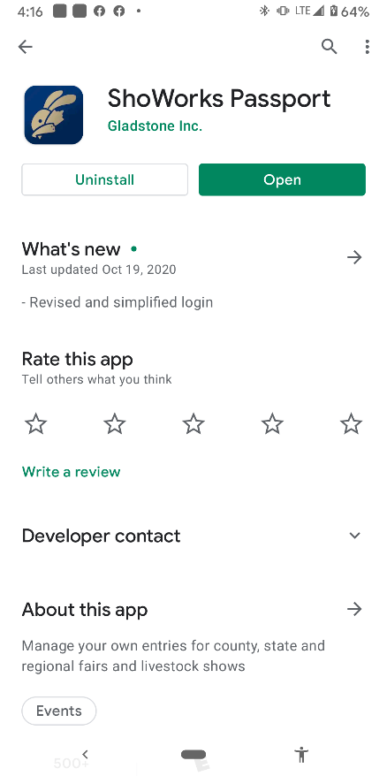
This is the app:

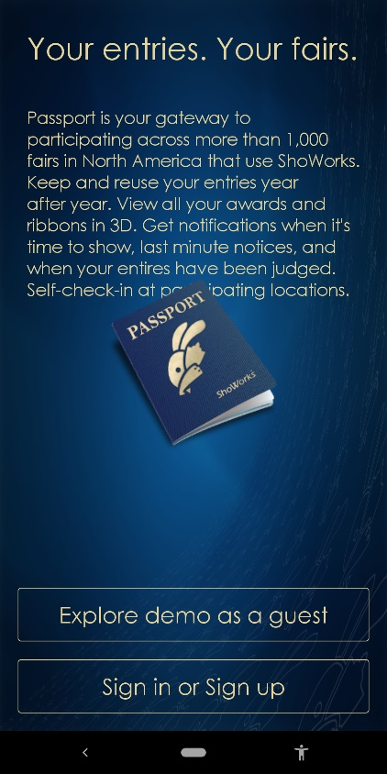
Sign in if you created an account
already. Sign up if you have not yet
created an account.

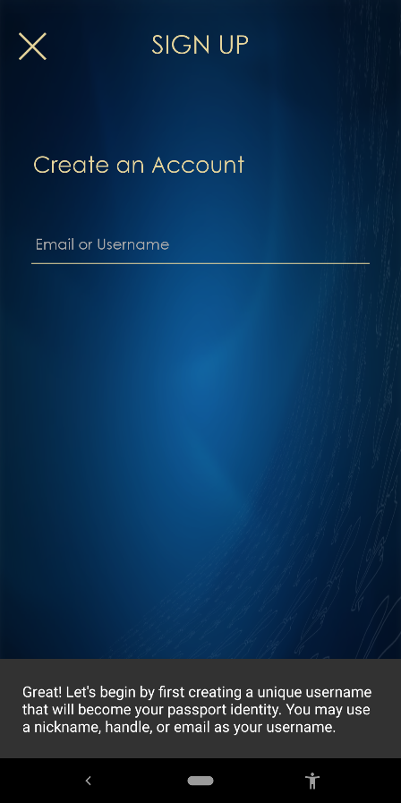
Create an account here.

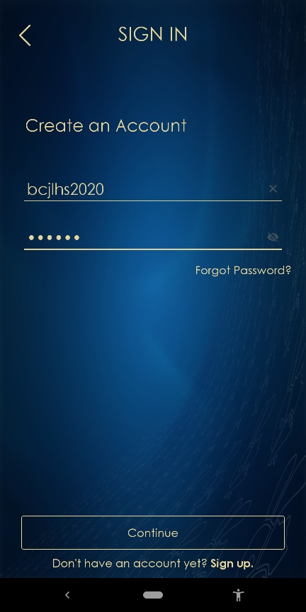
You have to make up your username,
you will want to make it specific to
the exhibitor. Create a password you’ll
remember!

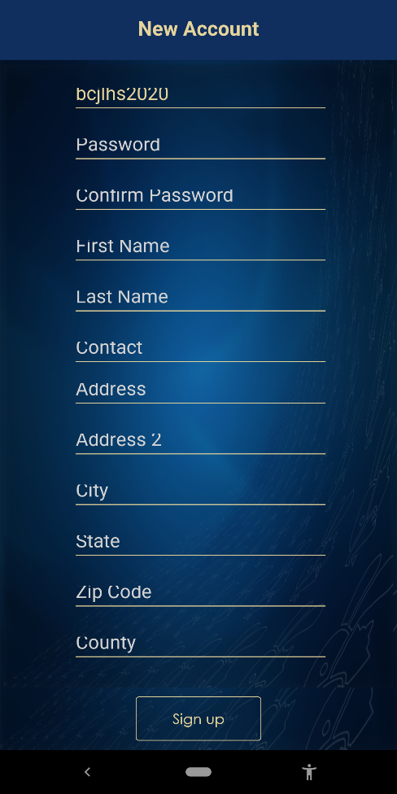
Make sure this information matches
exactly the information you entered
when you registered your exhibitor.

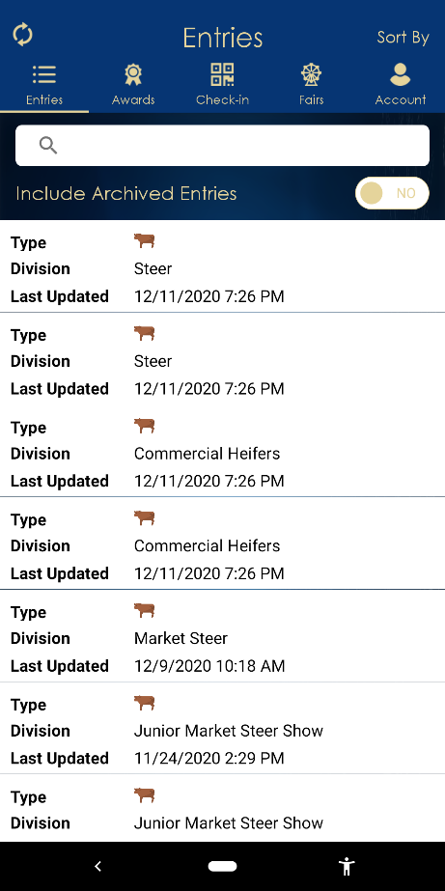
If you can see your entries, you’re good
to go! If not, you may have to log in to
a computer to grab your entries.

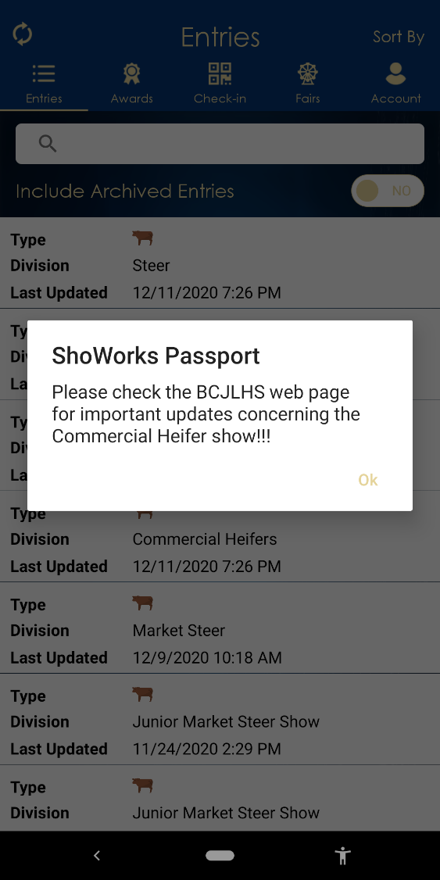
Notifications from the ShoWorks
office will appear on your phone.

