***Clerical correction; page 36***
(Classes to choose from were numbered incorrectly)

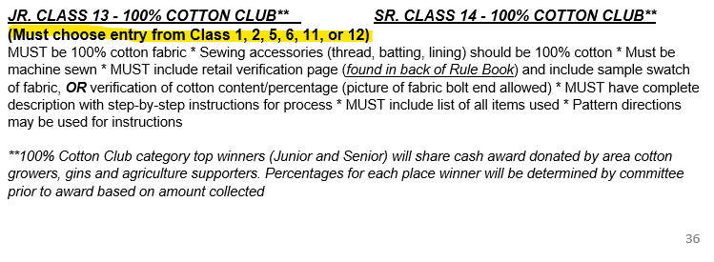

***Clerical Correction; page 37***
(Junior and Senior Miscellaneous Classes were numbered incorrectly)

